Appendix F: Data and Forecasting

Introduction
As part of the 2026 TRPA Housing Element Environmental Impact Statement (EIS), TRPA prepared regional and transportation forecasts for the years 2035 and 2050. The regional forecast includes changes in development, population demographics, and visitation. The transportation forecast includes the EIS transportation project list, as well as the transportation strategies. The regional forecast and the transportation infrastructure forecast are implemented in the Tahoe travel demand model and the Trip Reduction Impact Analysis (TRIA) tool to allow planners to assess the efficacy of policies and projects that promote the goals of the Regional Plan and the EIS.

Development Forecast Summary
The 2035 and 2050 forecast years build upon the 2026 model base year. The forecast includes a variety of projections related to land use and the characteristics of the region’s traveling population in the forecast years; this population includes residents, visitors, and commuters. The forecast years of 2035 and 2050 were selected to meet specific regulatory requirements of the California Sustainable Communities Strategy (SCS) and Federal RTP requirements and to align with the forecasts periods used by nearby regional partners, including the Sacramento Area Council of Governments (SACOG), Carson Area Metropolitan Planning Organization (CAMPO), the Regional Transportation Commission of Washoe County (RTC-Washoe), and the Bay Area Metropolitan Transportation Commission (MTC).
Three alternatives are analyzed: Alternative 1 (Baseline housing package), Alternative 2 (Additional Affordable Housing), and Alternative 3 (Housing Activation / Increased Occupancy). The alternatives share the same residential unit allocations across local jurisdictions but differ in regional (TRPA) pool utilization, occupancy adjustments, and employment assumptions. Table 1 below summarizes key parameters for each alternative, and the sections that follow describe forecast outcomes for each.
Metric | Base Year  (2026) | Alt 1  2035 | Alt 1  2050 | Alt 2  2035 | Alt 2  2050 | Alt 3  2035 | Alt 3  2050
Total Residential Units | 49,950 | 51,062 | 54,197 | 51,469 | 55,435 | 51,062 | 54,197
Occupied Residential Units | 23,655 | 24,687 | 26,507 | 24,997 | 27,750 | 25,019 | 27,362
Residential Occupancy Rate | 47.4% | 48.3% | 48.9% | 48.6% | 50.1% | 49.0% | 50.5%
Total Persons | 54,679 | 55,588 | 57,608 | 56,281 | 60,244 | 56,340 | 59,472
Total Employment | 26,737 | 27,150 | 27,580 | 27,294 | 27,970 | 27,249 | 27,850
Hotel/Motel Occupied | 4,906 | 5,213 | 5,213 | 5,213 | 5,213 | 5,213 | 5,213
K-12 + College Enrollment | 9,309 | 9,383 | 9,558 | 9,444 | 9,783 | 9,449 | 9,715
Table: Development Forecast Summary by Alternative
Parameter | Alternative 1  (Baseline) | Alternative 2  (Affordable Housing Focus) | Alternative 3  (Housing Activation)
Total New Residential Units | 3,377 | 4,615 | 3,377
Bonus Units | 1,246 | 1,246 | 1,246
General Units | 2,021 | 2,021 | 2,021
ADU | 110 | 110 | 110
Affordable Units | 0 | 456 | 0
Moderate Units | 0 | 285 | 0
Achievable Bonus | 0 | 228 | 0
JADU | 0 | 98 | 0
Achievable General | 0 | 57 | 0
Affordable by Design | 0 | 114 | 0
Additional units vs Alt. 1 | — | +1,238 | 0 (same units)
Occupancy Adjustment 2035 | None | None | +332 occupied units
Occupancy Adjustment 2050 | None | None | +855 occupied units
Town Center Employment Add-back | No | Yes | Yes
Population Target (2035) | 55,592 | Modeled | Modeled
Population Target (2050) | 57,611 | Modeled | Modeled
MF Share (default / Affordable) | 35% / — | 35% / 100% | 35% / —
Table 1: Alternative Descriptions and Key Parameters
Residents– The forecast projects Lake Tahoe’s 2035 and 2050 full-time residential population to increase slightly. The Region’s population has been steady for the last 10 years, and the projected slight increase is influenced by a suite of factors. First, the number of regional housing units will increase as residential allocations are distributed and workforce housing/affordable housing programs are implemented using residential bonus units. Second, the residential occupancy rate – the proportion of homes occupied by residents – is expected to increase slightly due to implementation of workforce and affordable housing initiatives as local and regional efforts to increase the housing supply for local residents take effect. The downward trend in regional population between 2000 and 2010 was likely influenced by the declines in gaming and associated job loss. The precipitous declines in gaming revenues observed in the early part of the century following the opening of casinos in northern California have not continued into the second decade as revenues appear to have stabilized.
The income distribution of the residential population has shifted significantly in recent years, with more high-income households and fewer low-income households. For the forecast period, with the proposed increase in workforce and affordable housing, TRPA anticipates that the recent upward trends in household income will stabilize; the forecast shows the same distribution of occupied households by household income in 2050 as was observed in 2022. School enrollment will increase slightly as a result of overall population growth, however as census data indicates that the age distribution of Tahoe’s population has increased in recent years, the forecast assumes slightly less of an increase in school enrollment than the overall population increase as the data trends show fewer residents with school-aged children. Employment will also increase as additional Commercial Floor Area (CFA) and Tourist Accommodation Units (TAU) are constructed throughout the region.
Income Category | Base Year  (2026) | Alt 1  2035 | Alt 1  2050 | Alt 2  2035 | Alt 2  2050 | Alt 3  2035 | Alt 3  2050
Low Income Occ. Units | 9,929 | 10,563 | 11,441 | 10,709 | 11,650 | 10,563 | 11,441
Medium Income Occ. Units | 4,838 | 4,889 | 5,142 | 4,952 | 5,607 | 5,042 | 5,556
High Income Occ. Units | 8,881 | 9,235 | 9,924 | 9,336 | 10,493 | 9,414 | 10,365
Total Occupied Units | 23,655 | 24,687 | 26,507 | 24,997 | 27,750 | 25,019 | 27,362
Low Income Share | 42.0% | 42.8% | 43.2% | 42.8% | 42.0% | 42.2% | 41.8%
Medium Income Share | 20.5% | 19.8% | 19.4% | 19.8% | 20.2% | 20.2% | 20.3%
High Income Share | 37.5% | 37.4% | 37.4% | 37.3% | 37.8% | 37.6% | 37.9%
Table: Occupied Unit Income Distribution by Alternative
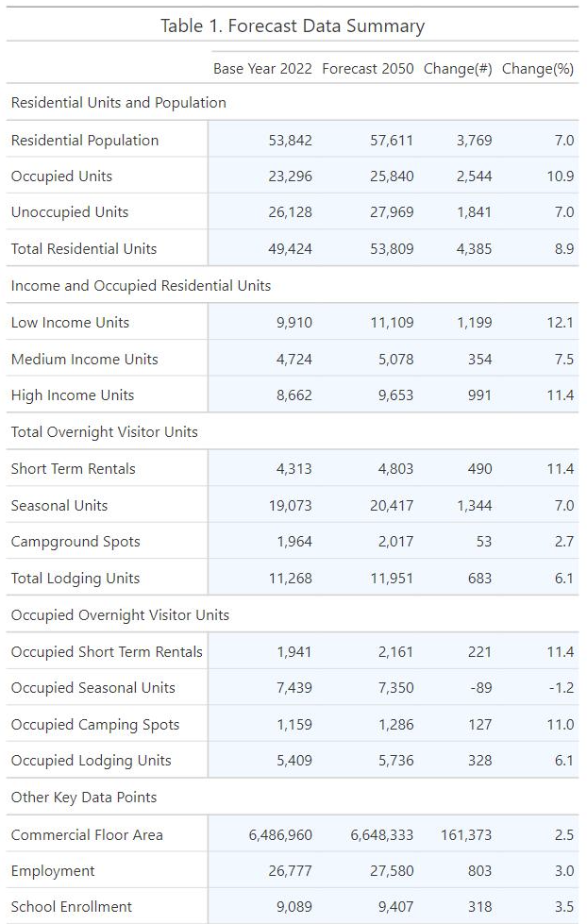
Visitation – The forecast projects slight growth in both day and overnight visitation. This forecasted increase is based upon the projected population growth in the mega-region (Bay Area/Sacramento/Reno), and the recovery to pre-Covid occupancy rates at hotels. This increase in visitation will result in an increase in the number of occupied overnight lodging units and short-term rentals. The forecast assumes a return to pre-Covid occupancy rates for seasonal homes. These rates have increased during the past couple of years with increased remote work opportunities during the pandemic. However, recent data suggests that workers are returning (or being required to return) to their offices more frequently, so the second home occupancy rate was reduced to 2018 levels.

Forecast Methodology
The overall approach to forecast development was to apply the best available information and data. The development rate forecast was informed by a review of historical development rates, and an assessment of the performance of past forecasts. The forecast differs from past forecasts in at least two ways:
- More rational development rates – Prior forecasts have generally assumed that full build out of the Region would occur. Historic development rates have not kept pace with those forecasts (additional detail on observed rates is available in the data trends appendix). This forecast refines past methodologies by placing greater weight on observed development rates.
- Development rights system - significant changes were made to the development rights system to accelerate the attainment of threshold standards and Regional Plan goals and policies. The changes enable easier conversion between types and facilitate the attainment of state housing mandates.
The forecasts contained in this document represent a realistic view of the continued build out of the Lake Tahoe Regional Plan. Prior forecasts by TRPA had projected significantly faster growth and a faster consumption of the remaining development rights. The annual rate of consumption for commercial floor area and tourist accommodation units were adjusted to align with observed trends since the adoption of the 2012 Regional Plan update. Additionally, the forecast assumes that not all the remaining development potential for commercial floor area and tourist accommodation units will be constructed by 2050.

Residential Units
There are currently 49,950 residential units in the Region (based on TRPA records); according to the occupancy rates published by the U.S. Census Bureau 2022 American Community Survey (ACS) applied to 2026 parcel data, an estimated 23,655 residential units (47%) are occupied by full-time residents and 26,295 units (53%) are not occupied by full-time residents . Approximately 20% of existing residential units in the region are multi-family units (approximately 9,885 units) and 80% of existing units (39,539) are single-family units. By 2050, between 4,247 and 5,485 additional units are expected to be constructed depending on the alternative, bringing the total number of residential units to between 54,197 and 55,435. This includes the construction of additional single-family and multi-family residential units distributed per zone proportions (default 50% SF, 35% MF, 15% infill); Alternative 2 has a higher multi-family share due to Affordable pool units (100% multi-family). Forecasts of residential projects in the California jurisdictions are sufficient to accommodate the Regional Housing Needs Assessment (RHNA) Cycle 5 (2013-2021) and Cycle 6 (2022-2031). However, local housing needs assessments have identified a greater number of affordable and workforce housing units needed beyond what the forecast assumes will be newly constructed and occupied. The conversion of existing housing from market rate to workforce or affordable housing would also be required to fully meet the housing needs identified. (U.S. Department of Commerce, 2022)
All remaining residential allocations (1,892) are allocated and constructed in the forecast. This includes the award and construction of all residential bonus units (1,448) and all currently banked residential units (345) by 2050. The forecast also includes the conversion of 100,000 square feet of CFA and 300 TAUs to residential units, which will generate an additional 350 multi-family and 350 single-family units. The projected conversions are consistent with conversion trends since the adoption of the conversion programs and observed development rights utilization rates. The observed trends indicate a net conversion from CFA and TAUs to Residential.
Jurisdiction | Bonus Units | General Units | ADU | Alt 1 Total | Alt 2 Total | Alt 3 Total
City of South Lake Tahoe (CSLT) | 89 | 395 | 0 | 484 | 484 | 484
Douglas County (DG) | 67 | 160 | 0 | 227 | 227 | 227
El Dorado County (EL) | 0 | 281 | 0 | 281 | 281 | 281
Placer County (PL) | 582 | 41 | 0 | 623 | 623 | 623
Washoe County (WA) | 120 | 196 | 0 | 316 | 316 | 316
TRPA (Regional Pools) | 388 | 948 | 110 | 1,446 | 2,684 | 1,446
TRPA — Affordable | — | — | — | — | 456 | —
TRPA — Moderate | — | — | — | — | 285 | —
TRPA — Achievable Bonus | — | — | — | — | 228 | —
TRPA — Achievable General | — | — | — | — | 57 | —
TRPA — Affordable by Design | — | — | — | — | 114 | —
TRPA — JADU | — | — | — | — | 98 | —
Total | 1,246 | 2,021 | 110 | 3,377 | 4,615 | 3,377
Table 2: New Residential Unit Allocations by Jurisdiction and Alternative
Several key assumptions informed the spatial distribution of residential development in the forecast. First, new residential units were allocated to projects known to be in the pipeline, including multi-family and affordable-/moderate-income projects on public lands. This includes 710 units expected to be built on California Tahoe Conservancy asset lands, redevelopment successor agency parcels and other publicly owned parcels where large multi-family and affordable/moderate-income housing projects are likely to be constructed. For multi-family development on private properties, where the exact number of units to be constructed was not fully known, a computer-generated random selection distributed units to vacant buildable multi-family and existing underbuilt residential parcels throughout the region. For these parcels, the number of units allocated was 60% of the maximum allowable buildout based on current zoning, coverage constraints, and density restrictions. This assumption is consistent with observed buildout patterns, and conservative in that it distributes new residential development throughout the region (rather than modeling the most compact possible pattern). Multi-family units were only assigned to parcels that are currently zoned for multi-family residential, meet density requirements, and that have remaining coverage available to support additional units. Finally, the remaining private residential units were constructed as single-family units through random assignment to vacant buildable properties throughout the region. Figures 3 – 5 show the impact of these added residential units on housing density, highlighting that the impacts are concentrated in town center areas that may already have similar density.

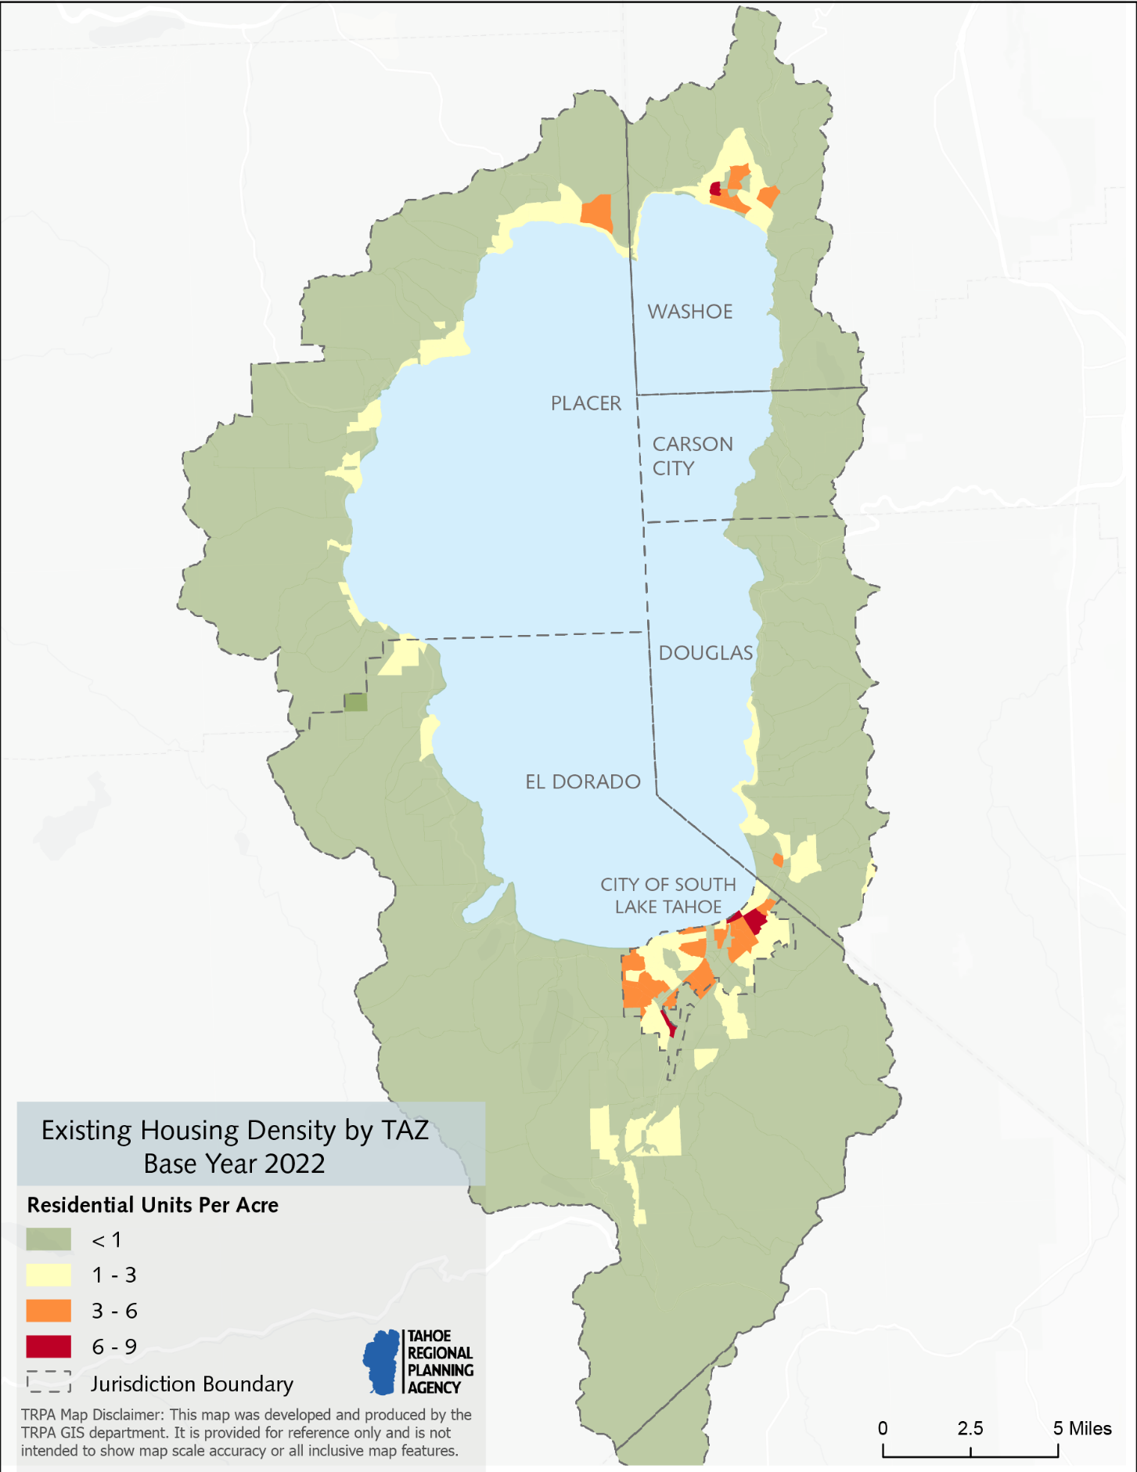
Figure 2: Existing Housing Density by TAZ Base Year 2026
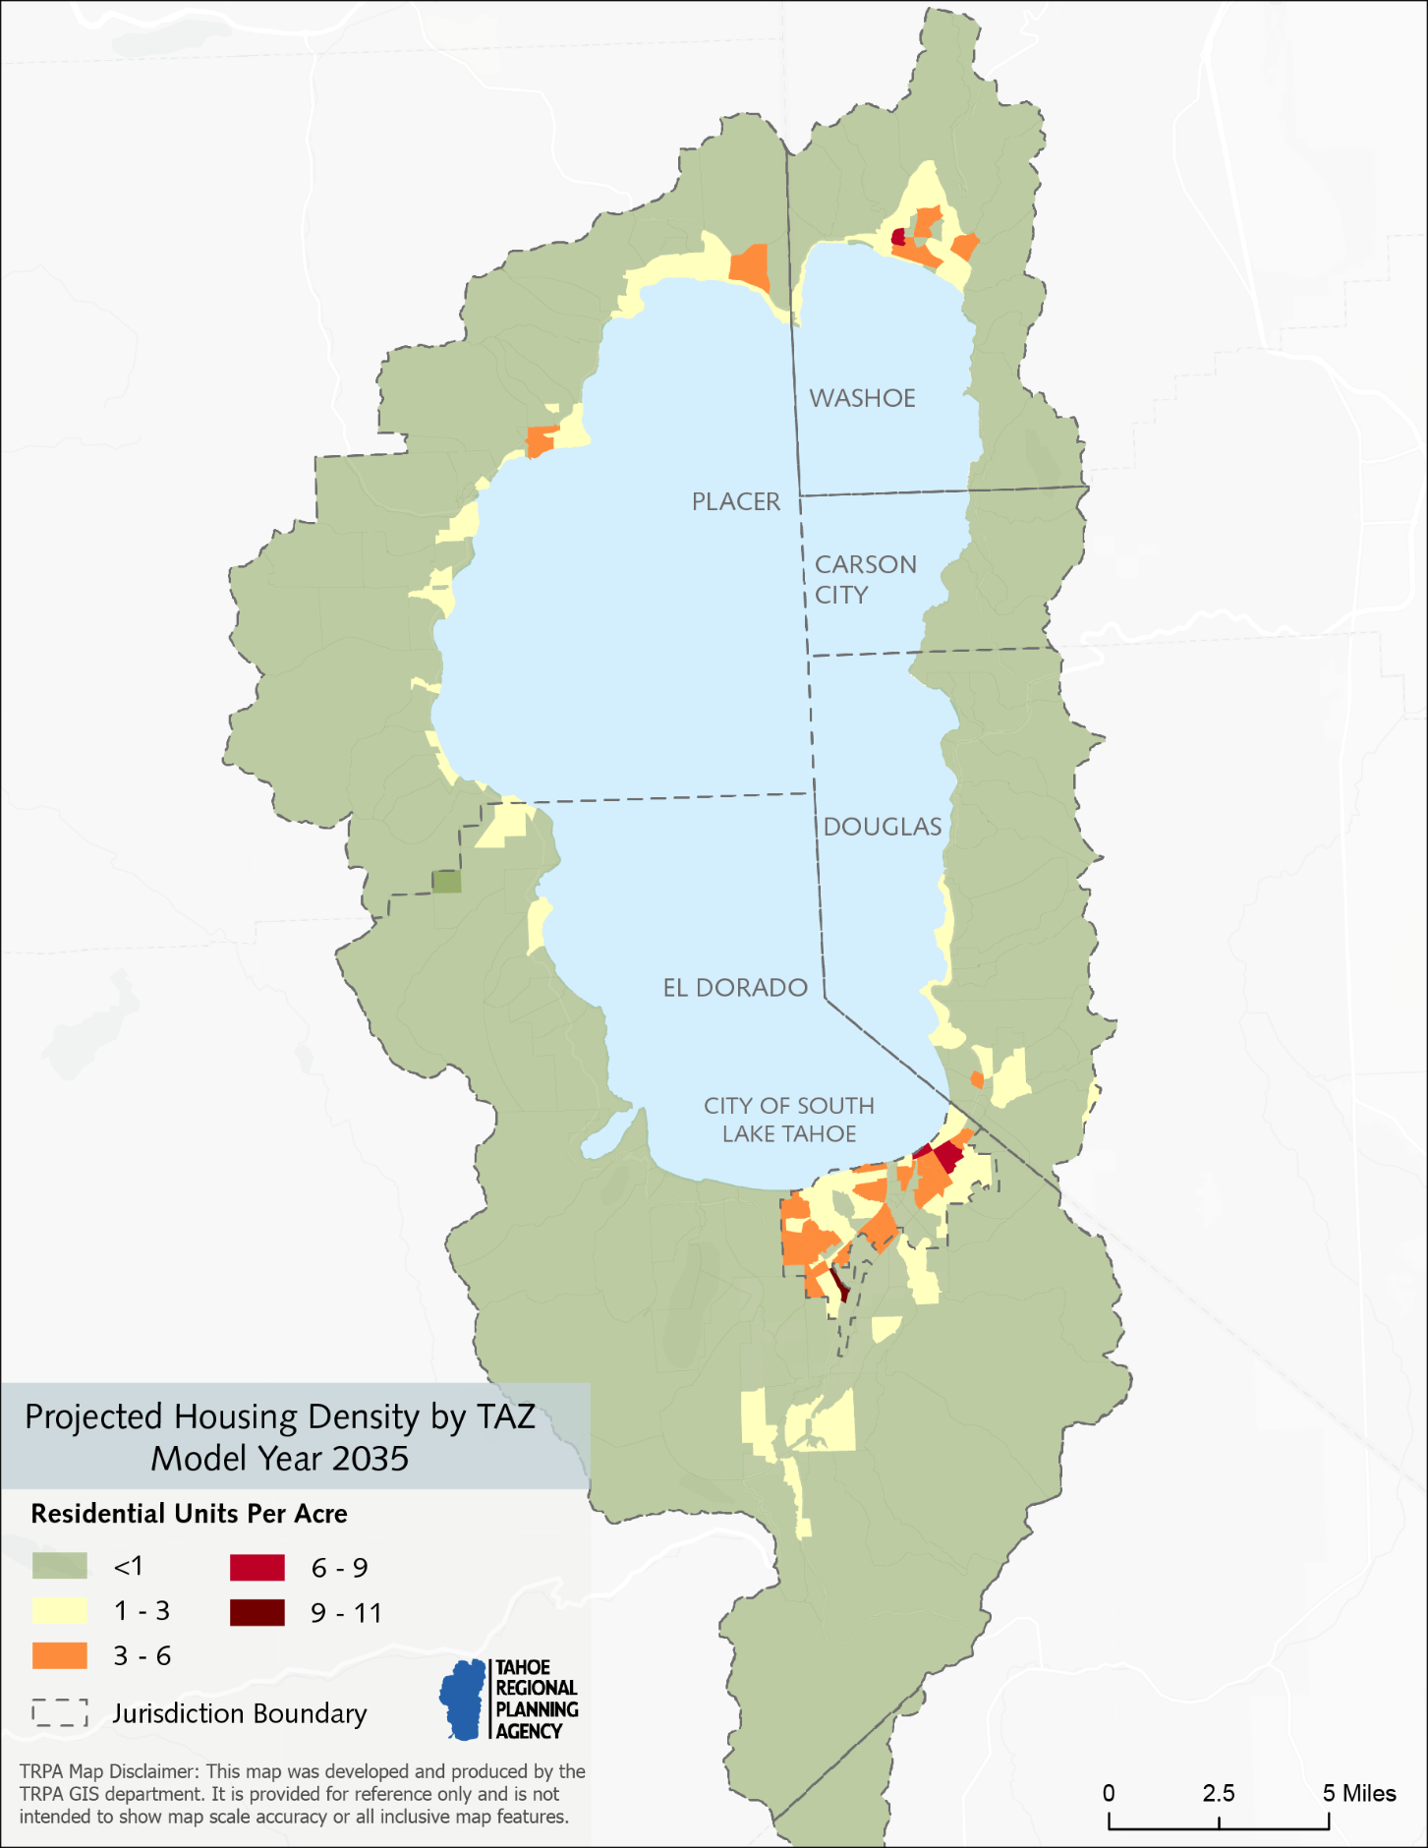
Figure 3: Projected Housing Density by TAZ Model Year 2035
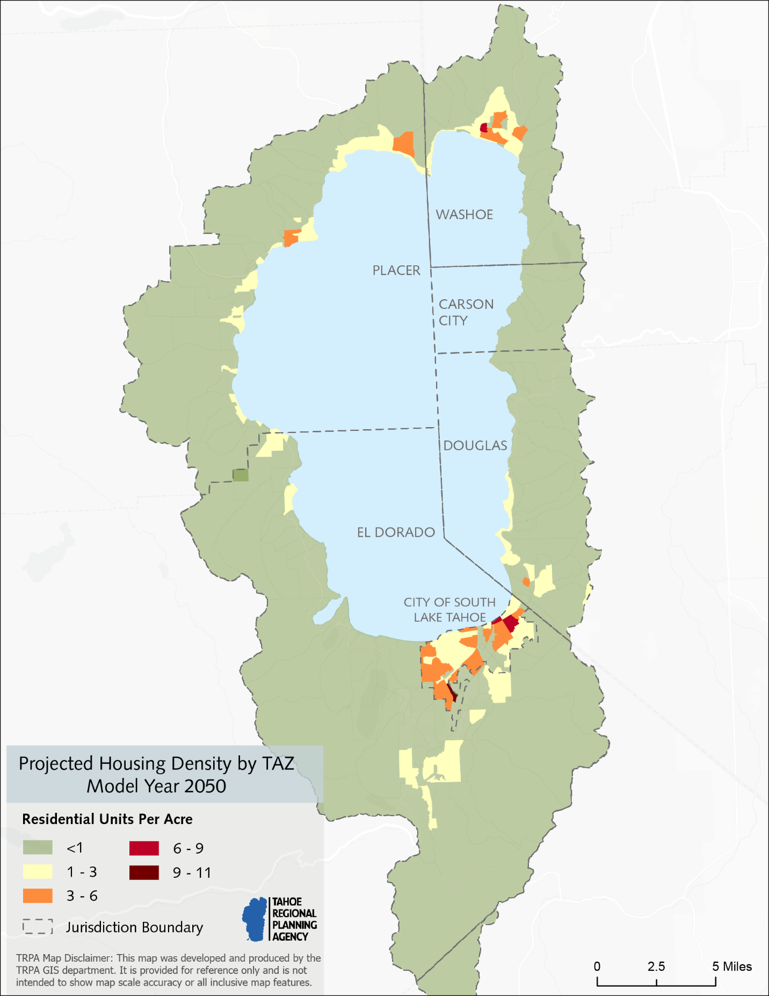
Figure 4: Projected Housing Density by TAZ Model Year 2050

Residential Occupancy Rate
The 2020 Decennial Census estimates that the proportion of occupied housing units in the Tahoe Region was 50% in 2020 (U.S. Department of Commerce, 2023). The remaining 50% of the regional housing supply not occupied by full-time residents is classified by the ACS as seasonal use (44%, including short-term rentals) or otherwise vacant (6%). These figures were slightly higher than the 2010 Census, which reported that 49% of Tahoe’s housing units were occupied, 44% were seasonal use, and 7% were otherwise vacant.
The 2020 housing occupancy data varies significantly by jurisdiction and community around the Tahoe Region, with some communities on the west shore of Tahoe approaching 70% to 80% seasonal and vacant housing units, and some east shore communities at 33% seasonal and vacant.
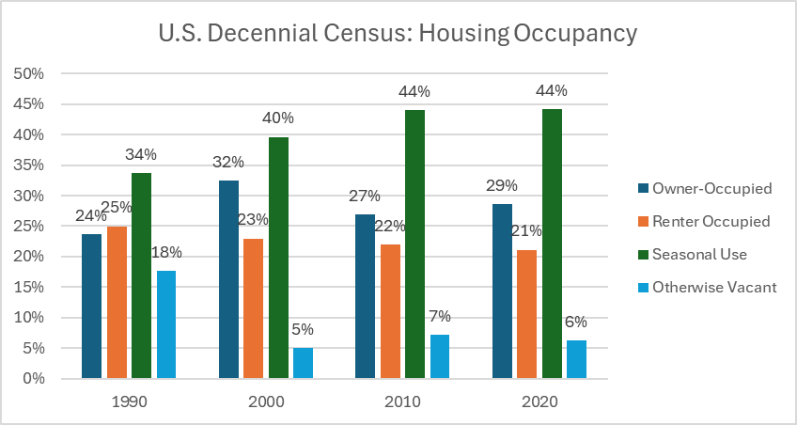
Figure 5: US Decennial Census: Housing Occupancy in the Tahoe Region
The forecast includes an increase in the proportion of residential units occupied by full-time residents (owner-occupied and renter-occupied) and assumes a return to pre-Covid level of second home occupancy. Three factors are expected to contribute to the shift: 1) Housing Initiatives to support construction of new workforce, achievable, and affordable housing in the region, 2) Housing initiatives to support the transition of the existing stock of residential units from second homes and short term rentals to resident-occupied units, and 3) Short term rentals regulations. Additional details on each factor are provided below.
- Housing initiatives to promote new workforce and income-restricted housing: The development forecast includes construction of all of the remaining 1,448 residential units from the TRPA residential bonus unit pool. Residential Bonus Units are awarded as transfer incentives for relocating remote development into town centers, and for the construction of affordable/moderate/achievable housing. New housing constructed with Residential Bonus Units is required by TRPA Code to be deed-restricted to prohibit these housing units from being used for second homes or vacation rentals.
- Short term rental regulations: Since the 2020 RTP, there have been numerous changes in the regulation of short-term rentals by local jurisdictions.
  - Measure T in the City of South Lake Tahoe: Voters passed Measure T in the City of South Lake Tahoe in November 2018. The measure includes broad restrictions on short term rentals (STRs) outside select areas in the city. The restrictions went into effect on December 31, 2021. As a result of the measure, approximately 1,372 previously permitted VHRs were not renewed. In March of 2025, this measure was declared unconstitutional requiring the City to develop a short-term rental program once again. For Alternative 1, modeling considered the Measure T requirements in effect at the time the prior model was run. Alternative 3 accounts for increased residential occupancy that results from STR regulations across all jurisdictions. In TRPA’s model runs, the model considered these units residential units and assumed an average occupancy rate based on the census block occupancy rates. Trips/VMT were assumed in the Resident submodel based on residential trip rates and resident O/D behavior (as opposed to the visitor submodel, trip purposes/destinations). On average, residential units produce more vehicle trips/VMT than lodging and rental units. Other VHRs in the region were considered in the Visitor submodel. Future analyses will account for the number of permitted VHRs at the time of the input base year, and forecasts will generally assume full utilization of the maximum permits allowed by the jurisdiction. (City of South Lake Tahoe, n.d.)
  - Douglas County: In 2021, Douglas County adopted changes to its vacation home rental ordinance that placed a cap on the total number of permits available (600) in the Tahoe Township, placed caps on the number of permits available in each subdivision, established a tiered permit structure, created an advisory board, and substantially increased the penalties for violations. The current version of Douglas County’s Lake Tahoe Vacation Home Rentals ordinance (chapter 20.622 of the Douglas County Code) was adopted March 21, 2024. Under current regulations, vacation home rentals are either prohibited or heavily restricted in and north of Lincoln Park, with VHRs in allowed subdivisions limited to 15% of housing stock. Many neighborhoods have reached their caps, with additional permit requests added to a waitlist. (Douglas County Board of County Commissioners, 2024)
  - El Dorado County: El Dorado County adopted a new county-wide VHR ordinance on December 2, 2020. This ordinance limited the number of permits in the Tahoe Basin to 900 permits. On August 24, 2021, the ordinance was amended to require a 500-foot buffer around all active VHR permits. El Dorado County’s permit cap was reached in May 2023. (El Dorado County, n.d.)
  - Placer County: Placer County adopted a STR ordinance in November 2019, going into effect in January 2020. This ordinance was repealed and replaced with the current STR ordinance on February 8, 2022, effective March 11, 2022, with later amendments. The current ordinance limits the number of STR permits east of Kingvale to 3,900 permits, with 3,227 permits active as of October 2024. About two-thirds of the active permits are located within the Tahoe Basin, with most of the remainder in the Northstar, Soda Springs, Schaffer’s Mill, and Olympic Valley/Alpine Meadows areas outside of the Tahoe Basin. There is no specific cap on Tahoe permits, though Placer County representatives have stated that the cap may be lowered if additional hotel or resort capacity is constructed. (Placer County Code Enforcement Services, 2024)
  - Washoe County: Unlike other jurisdictions in the Tahoe Basin, Washoe County does not place a limit on the number of STR permits that may be issued. The current Washoe County STR ordinance was adopted May 10, 2022. More recently, STR fees were increased, with the latest fee schedule becoming effective on July 1, 2024. Separate from county regulations, some homeowners’ associations in Washoe County ban STRs. (Washoe County Community Services Department, 2024)

Commercial Floor Area (CFA)
There are currently 529,880 square feet of unused commercial floor area in TRPA and local jurisdiction community/area plan pools. Since 2013, a total of 50,200 square feet of CFA has been allocated to projects; an average rate of 5,020 square feet of CFA per year. The forecast includes the construction of an additional of 78,676 square feet of CFA by 2035 (local jurisdiction pools) and approximately 161,373 square feet by 2050. The forecasted rate of development – 5,763 square feet - is higher than the observed rate since the 2012 Regional Plan, but lower than rates used in prior regional forecasts. CFA was allocated to known projects that have been permitted or are in the planning phase, but not constructed; remaining CFA was allocated to town centers and community plans or area plans using the observed proportions from recent allocations.
The forecast includes the conversion of 100,000 square feet of CFA to residential units, consistent with conversion trends since the adoption of the conversion program; recent trends indicate the net conversion from CFA and TAUs towards Residential. The converted CFA is forecasted to result in the construction of 400 additional residential units --200 multifamily units, and 200 single family units. At the end of the forecast period, 457,627 square feet of CFA remains unallocated or banked, and thus unconstructed.

Tourist Accommodation Units (TAU)
The forecast includes the construction of an additional 489 TAUs by 2035 and another 503 TAUs by 2050. The forecast includes the completed construction of all currently permitted projects using 854 banked TAUs and the use of 138 awarded TAU bonus units. Furthermore, the forecast includes the removal, banking, and conversion to residential of 300 existing units, including units at Lakeside Inn, that were considered as part of the baseline 2022 data but have been since removed, and Motel 6 that is expected to be removed in coming years. Not all TAUs allowed in the Regional Plan are forecast to be constructed by 2050; an estimated 326 TAUs will remain undeveloped through 2050 (204 TAU bonus units and 122 banked TAUs). The TAU development rights pool is not exhausted within the forecast horizon, because of the slow rate of TAU right utilization and construction over the past 30 years. No TAUs have been allocated to projects and constructed since adoption of the 2012 Regional Plan, and only 58 TAUs have been allocated since the adoption of the 1987 Regional Plan. TAUs were allocated to projects that are permitted but not yet constructed (Homewood, Boulder Bay, Edgewood Casitas, Tahoe City Lodge, and Chateau/Project 3). Bonus TAUs were assigned to permitted projects (Homewood, Boulder Bay, Tahoe City Lodge) and no additional allocations other than existing permits were included.
The forecast also includes the conversion of 300 TAUs to residential units, consistent with recent conversion trends since the adoption of the conversion programs; observed trends indicate the net conversion from CFA and TAUs and towards Residential.

Development Rights Forecast Summary
Total development in the Tahoe Region is capped by the Regional Plan. The type and rate of that development is further controlled by a complex system governing development rights in the Region. Development rights are land use units someone must acquire before a property is developed. Development rights include tourist accommodation units (TAUs), single and multi-family residential units of use (RUUs), and commercial floor area (CFA). Residential units of use (RUUs) are formed by combining a potential residential unit of use (PRU) and a residential allocation. The forecast differentiates between when a development right is allocated from TRPA or another jurisdiction’s pool and the final use of that development right. Development rights can be utilized in one of two ways; they can be used to construct a project (e.g. a house) or converted to a different type of development right. The forecast is grounded in projections about the utilization, transfer, conversion, and construction of development rights. Tables 2-4 summarize the fate of development rights in the forecast period.
- Table 3 summarizes new construction which influences land use in the future scenarios. Tables 4 and 5 provide background detail on the underlying accounting that enabled the development.
- Table 4 summarizes the expected utilization of development rights in their current type.
- Table 5 summarizes the expected conversion of development rights between types.
The forecast includes the net annual construction of 157 residential units, 5,763 square feet of commercial floor area and 25 tourist accommodation units (Table 2).
Table 2: Construction Forecast Summary
Development Right | Annual Rate | Alt 1 - 2035  Net Change | Alt 1 - 2050  Net Change | Alt 2 - 2035  Net Change | Alt 2 - 2050  Net Change | Alt 3 - 2035  Net Change | Alt 3 - 2050  Net Change
Residential Units | +varies | +1,112 | +4,247 | +1,519 | +5,485 | +1,112 | +4,247
Commercial Floor Area (sq ft) | +5,763 | +78,676 | +161,373 | +78,676 | +161,373 | +78,676 | +161,373
Tourist Accommodation Units | +varies | see note | see note | see note | see note | see note | see note

The forecast includes the utilization of allocation pools held by TRPA and local jurisdictions in the area plan, community plan, or plan area statement pools, as well as the use of bonus and incentive pools, special projects pools, and banked development rights (Table 3).
Table 5: Development Rights Utilization Forecast Summary
Development Right Utilization | Annual Rate | 2035  Net Change | 2050  Net Change
Residential Allocations | +varies | +varies | +varies by alt (see Alternatives Overview)
Residential Bonus Units | +52 | +676 | +1,246 (all alts) / +1,474 (Alt 2)
ADU Allocations | +varies | +varies | +110 (all alts)
Affordable/Moderate/JADU (Alt 2 only) | — | — | +1,238 additional (Alt 2 only)
Total Residential Rights | +varies | +1,112 to +1,519 | +4,247 (Alt 1/3) to +5,485 (Alt 2)
CFA Allocations (sq ft) | +6,052 | +78,676 | +169,452
CFA Special Projects Pool (Homewood) | +varies | +20,921 | +20,921
Banked CFA (Area-wide TRPA) | +varies | — | +71,000
Total CFA Utilization | +10,197 | +varies | +261,373
TAU Bonus Allocations | +5 | +65 | +138
Banked TAU Development | +31 | +403 | +854
Total TAU Rights | +36 | +468 | +992

The forecast includes the conversion of development rights between the various types of development (Table 4). TRPA approved a comprehensive update to Tahoe’s development rights system in 2018. This allows conversions between different types of development rights using environmentally-neutral exchange rates and makes development rights simpler to transfer around the Basin, keeping limits on Tahoe’s total development potential. The changes make it easier for the private sector to invest in redevelopment projects that benefit the Tahoe region and provide needed workforce housing. The projected conversions are consistent with conversion trends since the adoption of the conversion programs and observed development rights utilization rates. The observed trends indicate a net conversion that reduces CFA by 3,600 square feet and 11 TAUs and creates an additional 28 residential units each year.

Table 4: Development Rights Conversion Summary
Development Right Conversion | Annual Change  from Conversion | 2035  Net Change | 2050  Net Change
Net Conversions to Residential | +25 | +325 | +700
Net CFA Conversions to Residential | –3,600 sq ft | –46,800 sq ft | –100,000 sq ft
Net TAU Conversions to Residential | –11 | –143 | –300

Employment
The most recent region-wide data estimates that summertime employment in the Tahoe region decreased by 6% between 2018 and 2022, from 28,604 to 26,737 jobs. The forecast projects a small increase in employment in the region as a result of increased visitation, construction of new CFA and TAUs, and population growth. In the 2026 model base year there are an estimated 28,558 workers living in the Tahoe region and 26,737 jobs (some residents hold jobs outside the region). The forecast projects continued growth of jobs in the region, with additional new jobs (Alt. 1: +843, +3.2%; Alt. 2: +1,233, +4.6%; Alt. 3: +1,113, +4.2%) in the region by 2050. The number of external workers (those commuting into the region for work) is not expected to grow because more workers are expected to find housing locally as a result of the regional housing initiatives.
The following table summarizes employment forecasts for all three alternatives. Alternative 2 and Alternative 3 include additional employment in town centers generated by new occupied housing units, using TAZ-level town center job multipliers.
Category | Base Year  (2026) | Alt 1  2035 | Alt 1  2050 | Alt 2  2035 | Alt 2  2050 | Alt 3  2035 | Alt 3  2050
Retail | 3,711 | 3,778 | 3,855 | 3,778 | 3,855 | 3,778 | 3,855
Service | 7,503 | 7,632 | 7,777 | 7,632 | 7,777 | 7,632 | 7,777
Recreation | 2,248 | 2,286 | 2,318 | 2,286 | 2,318 | 2,286 | 2,318
Gaming | 2,564 | 2,580 | 2,598 | 2,580 | 2,598 | 2,580 | 2,598
Other | 10,711 | 10,874 | 11,032 | 11,018 | 11,422 | 10,973 | 11,302
Total | 26,737 | 27,150 | 27,580 | 27,294 | 27,970 | 27,249 | 27,850
Change from Base | — | +413 | +843 | +557 | +1,233 | +512 | +1,113
Table: Employment Forecast by Alternative

Visitation
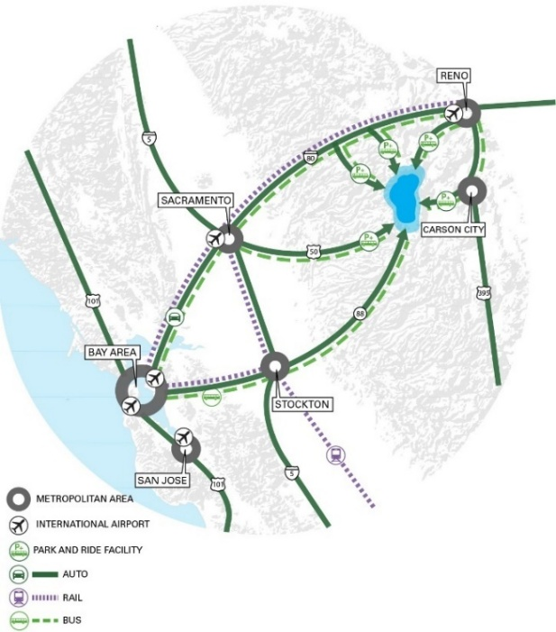
The forecast includes an increase in visitation which is influenced by several factors. The Tahoe Region is located near and draws visitors from several regions that are projected to experience between 20% and 30% growth in the coming decades (Figure 5, Table 5). The Sacramento Council of Governments (SACOG), predicts that population in the greater Sacramento Region will grow 26% by 2050 (Sacramento Area Council of Governments, 2022). Farther west, but still within the Tahoe Mega-Region, the Association of Bay Area Governments (ABAG) forecasts 30% population increase by 2050 (Association of Bay Area Governments, 2021). To the north and east of Tahoe, RTC-Washoe predicts a 28% growth in population in the Reno/Sparks Metropolitan area by 2050 (Regional Transportation Commission of Washoe County, 2024) and the Carson Area MPO predicts a 23.5% growth in population (Carson Area Metropolitan Planning Organization, 2024). Population growth in the mega-region is likely to create increased demand for recreation opportunities and the unique experience that Tahoe provides.
Figure 6: Tahoe Mega-Region
Table 5: Mega-Region Growth Forecasts
Location | Metric | Growth | Forecast Year | Source
Sacramento Region | Population | +23% | 2050 | SACOG 2025 MTP/SCS
Sacramento Region | Employment | +23% | 2050 | SACOG 2025 MTP/SCS
Reno/Sparks Metro | Population | +28% | 2050 | RTC-Washoe 2050 RTP, 2018
Reno/Sparks Metro | Employment | +34% | 2050 | RTC-Washoe 2040 RTP, 2018
Carson City Region | Population | +23.5% | 2050 | CAMPO 2040 RTP, 2018
San Francisco Region | Population | +30% | 2050 | ABAG 2050 RTP

Population growth outside the region over the last 20 years has not translated to a linear increase in visitation into the region. Therefore, the forecast does not project increases in visitation in proportion to the projected growth in the mega-region. It is uncertain why past population growth has not translated in a linear fashion to increased visitation, but working theories include the decline in popularity of the local casinos as the gaming experience has become more widely available, limited tourist accommodation capacity, the limited roadway capacity into the region and associated willingness to travel to the region given the longer travel times.
The visitation forecast is comprised of related but independent projections regarding the expected characteristics of both the number and occupancy of overnight lodging accommodations types, and day visitation. The visitation forecast can be broken down into overnight visitors (staying in Hotels/Motels/Casinos/STRs/Private homes) and day visitors. The number of occupied overnight visitor units is forecast to grow slightly by 2050, with hotel/motel TAU units increasing from 4,906 to 5,213 (6.3%) as new units are constructed.
Overnight Visitors in Hotels/Motels/Casinos – In the 2026 model base year, 4,906 of the region’s 11,805 TAUs are occupied (48%) during the modeled day. The forecast includes the construction of an additional 683 TAUs by 2050, a 5.8% increase in tourist accommodation units. TRPA is assuming added TAUs are occupied at the same rate as current units, keeping the occupancy rate the same in the future. As a result of additional unit availability from new TAU construction, the actual number of occupied Hotel/Motel/Casino units increases by 5.8% in 2050.
Overnight Visitors in STRs – In 2022, TRPA estimated that there were 4,313 permitted STRs in the Tahoe Region, which comprised approximately 13% of all existing residential units and 23% of the vacant housing units. On the model day, 45% of the units, or 1,941 properties are occupied. The forecast projects that the number of occupied STRs is relatively flat in the forecast years, with an assumption that the number of Douglas County and Placer County units increases to the legal cap. Future year STR occupancy rates were decreased slightly from 2022 numbers to account for recent data indicating that California side summer weekday visitors have decreased since 2022, as well as statements by Placer County indicating that there are plans to reduce the county STR cap when more hotel units become operational.
Overnight Visitors in Seasonal Units – Seasonal units are residences within the model that are not claimed as the primary residence for the owner. Within the model they could be occupied by the owner, friends of the owner, time-shares, informally rented, but are not accounted for included in the total of STRs. These units comprise approximately 36% of the total housing market in the region, of which 37% were estimated to be occupied on the modeled day in the 2018 base year. During Covid, the occupancy rate for seasonal units increased significantly to 45% as seasonal homes were used more frequently. The forecast assumes a return to pre-Covid occupancy rates for seasonal homes. Recent data suggests that workers are returning (or being required to return) to their offices more frequently, so the current model returned the second home occupancy rate to the 2018 levels. The proportion of seasonal units in the region has grown in the last 10 years. The proportion of seasonal units is not forecast to continue to increase, due to three factors: 1) the construction of additional workforce housing units which cannot be used for second homes, 2) initiatives focused on making the existing stocking more affordable for workers and residents, and 3) the conversion of some existing vacation rentals to resident housing. As a result of the increase in the total number of homes in the region the number of seasonal units increases by 7% in 2050.
Day Visitors – Day visitation is forecast to increase as a result of population growth in the mega-region, at a rate slightly faster than overnight visitation. Day visitors are one of the more challenging travel parties to forecast. The model assumes the factors that drive overnight visitation are positively correlated with factors driving day visitation. The relationship between these two types of visitors was established as part of the calibration and validation for the 2018 base year.
Passenger Traffic at Reno-Tahoe International Airport – The Reno Tahoe International Airport has a significant role in visitation to the Tahoe Region, as increases in the number of passengers through the airport can affect both overnight and day visitation to the Lake Tahoe. The Reno Tahoe Airport Authority publishes monthly data on passenger volumes through the airport (Figure 18). Passenger volumes dropped precipitously during the Covid-19 pandemic, with lower volumes through 2020 and 2021. By 2022, passenger volumes through Reno had recovered and exceeded 2018 levels. Passenger volumes have continued to rise since 2022, with the full year 2023 volumes reaching the highest level since 2007, and through August 2024, ten of the last twelve months have recorded the highest monthly passenger volumes since 2018 (Reno-Tahoe Airport Authority, 2024).
Figure 7: Reno Tahoe International Airport: Total Passengers

School Enrollment
Like the overall population, school enrollment in the region has decreased in the last two decades. In recent years, school enrollment has remained relatively level on the California side, with decreases continuing on the Nevada side. Between 2003 and 2022, enrollment on the California side decreased by 17% , while enrollment on the Nevada side decreased by 46% . The forecast projects that school enrollment will increase by 0.8% to 5.1% depending on the alternative as new employment (additional jobs (varying by alternative; see Table below)) and residents (additional full time residents) are added to the region. As many of Tahoe’s new residents do not have school-aged children, school enrollment is expected to increase at about one-half the rate of population growth.(California Department of Education, 2024)(Nevada Department of Education, 2023)
Enrollment Level | Base Year  (2026) | Alt 1  2035 | Alt 1  2050 | Alt 2  2035 | Alt 2  2050 | Alt 3  2035 | Alt 3  2050
Elementary | 2,879 | 2,901 | 2,956 | 2,920 | 3,025 | 2,921 | 3,005
Middle School | 1,240 | 1,250 | 1,273 | 1,258 | 1,303 | 1,259 | 1,294
High School | 2,172 | 2,190 | 2,231 | 2,203 | 2,284 | 2,205 | 2,267
K-12 Subtotal | 6,291 | 6,341 | 6,460 | 6,381 | 6,612 | 6,385 | 6,566
College | 3,018 | 3,042 | 3,098 | 3,063 | 3,171 | 3,064 | 3,149
Total Enrollment | 9,309 | 9,383 | 9,558 | 9,444 | 9,783 | 9,449 | 9,715
Table: School Enrollment Forecast by Alternative

Figure 8: Tahoe Nevada School Enrollment, 2003-2023

Figure 9: Tahoe California School Enrollment, 2003-2023

Household Income
Household income is a key characteristic of the residential population, which influences travel behavior. Census data over the last nine years show that household income in the region is trending upwards towards higher incomes (U.S. Department of Commerce, 2022). Median annual income for households nationally rose to $74,580 in 2022, within California it is $91,905, and in Nevada it is $71,646 (Guzman 2024). Median income in the Tahoe Region has continued to grow in recent years, with the regional median remaining near or slightly above the national median. Between 2010 and 2018, the proportions of households in each income category have remained relatively stable, but in recent years, there has been a substantial shift towards higher-income households in Tahoe. Between 2018 and 2022, the proportion of households earning less than $25,000/year fell significantly, from 19% to 12%. Between 2018 and 2022, the number of households earning over $200,000/year doubled and those earning between $100,000 and $200,000 increased from 20% to 26%. While households earning less than $100,000/year outnumber households earning more than $100,000/year, only 54% of households earn less than $100,000/year. Some have suggested the decline in lower-income households has been driven by workers leaving the region in search of more affordable housing. The forecast projects that the relative distribution of household incomes will be maintained near the current level, with slight increases among those earning less than $75,000/year or above $125,000/year. Initiatives to provide workforce and affordable housing are expected to increase the regional housing availability at the lower end of income distribution.

Figure 10: Household Income Categories in Tahoe Region (% of Households, ACS 2010-2022)

Addendum

Transportation Projects & Strategies Forecast Summary

Transportation Projects
For the 2026 Housing EIS, several changes were made to better reflect the changing economy in the Lake Tahoe region, account for methodological advances and new technologies, and ensure future development is properly represented.
The largest single update in advance of the 2026 Housing EIS was a full revision of nonmotorized mode choice, creating a dedicated network to model bicycle and pedestrian trips. In previous model runs, it was only possible to route bicycle and pedestrian trips along the roadway network, without consideration for actual infrastructure. Furthermore, all nonmotorized modes were combined into a single “nonmotorized” option in the mode choice equations in previous model runs, not accounting for differences between bicycle and pedestrian travel. The new active transportation network included all current and future shared-use paths, as well as attributes for each roadway that indicate the type of bicycle facility. The routing function for bicycle and pedestrian modes favors shared-use paths, bicycle-friendly facilities, and low-volume streets in decreasing priority, only routing along high-traffic and high-speed roads when unavoidable. The effect of this new network is the ability to incorporate projected active transportation projects into the model, greatly improving the accuracy of projected active transportation trips and ensuring that the model can properly represent recreational trips and benefits the trail network can provide to the regional economy.
With both nonmotorized network improvement and improvements in available data, TRPA and its contractors modified mode share to best reflect current behavior as shown by TRPA’s monitoring program, big data, and surveys from around the United States. Walk trips are capped at 3 miles in the model, with increasing cost for longer trips, while bicycle trips have no limit, though mode share decreases with distance and mode share for trips over 8 miles in length is less than 0.5%. The changes resulted in increased nonmotorized model mode share, particularly for overnight visitors and seasonal residents, with approximately one-third of overnight visitor and seasonal resident trips occurring by nonmotorized modes. Over half of trips shorter than one-half mile and over 40% of trips shorter than one mile use nonmotorized modes, a large increase from previous assumptions. The new calibration targets provided by TRPA’s consultants also include some initial E-bike use, reducing reliance on TRPA’s off-model tools to evaluate the projected effect of E-bikes.
Yet another significant change to the TRPA model involved a recalibration of origin-destination trip pairs to better reflect modern travel patterns. Over the past two decades, there has been a large shift away from casino visitation to recreation trips, and TRPA expects this shift to be permanent. Therefore, it was important to recalibrate to ensure that the impacts of proposed recreation and hotel projects are properly accounted for. This recalibration used StreetLight data to examine the start and end points of trips and use that information to make modifications to the model. The analysis performed by TRPA’s contractors indicated that the prior model was overestimating trips to and from the south shore casino core while underestimating trips to recreation sites across the region. Using the results of this analysis, trip patterns were recalibrated to ensure that recreation and gaming travel was properly represented.

Transportation Strategies
See attachment at end of document

References

Association of Bay Area Governments. (2021). Plan Bay Area 2050 Forecasting and Modeling Report. San Francisco.
Carson Area Metropolitan Planning Organization. (2024). 2050 Regional Transportation Plan. Carson City, Nevada.
City of South Lake Tahoe. (n.d.). Measure T. Retrieved from City of South Lake Tahoe: https://cityofslt.us/2418/Measure-T
Douglas County Board of County Commissioners. (2024, March 21). Chapter 20.622: Lake Tahoe Vacation Home Rentals. Douglas County Code. Minden, Nevada: Douglas County. Retrieved from https://www.douglascountynv.gov/common/pages/DownloadFileByUrl.aspx?key=Saa9swlNqveUYCQRdoh9q6nHI4aw3oLFXiatih5MFm5SIGRV3cTmKuWcX%2f%2bel8qQwh2ceV0q8iKNsz52mT9Oz5X8MpJMUaxgXopGsO0fimm9EiFcmvaC6Utgv9XvNa2ZYC%2buVUaaZBRBn570fSbtJmfBpgnLWZjbkuVsmolx%2bxoMv64
El Dorado County. (n.d.). VHR Ordinance Information. Retrieved from El Dorado County: https://www.eldoradocounty.ca.gov/Services/My-Property/Vacation-Home-Rentals-Division/VHR-Ordinance-Information
Placer County Code Enforcement Services. (2024). Short-Term Vacation Rental Program. Retrieved from Placer County Community Development Resource Agence: https://www.placer.ca.gov/6109/Short-Term-Rental-Program
Regional Transportation Commission of Washoe County. (2024). 2050 Regional Transportation Plan. Reno, Nevada.
Reno-Tahoe Airport Authority. (2024, October). About the Reno-Tahoe Airport Authority. Retrieved from Reno-Tahoe International Airport: https://www.renoairport.com/airport-authority/about/
Sacramento Area Council of Governments. (2022). Sacramento Region Draft Growth Projections. Sacramento, California.
U.S. Department of Commerce. (2022). American Community Survey. Washington, DC.
U.S. Department of Commerce. (2023). H14: Occupied Housing Units. Washington, DC.
Washoe County Community Services Department. (2024, July 1). Short Term Rentals. Retrieved from Washoe County, Nevada: https://www.washoecounty.gov/csd/planning_and_development/short_term_rentals/index.php

See https://tahoe.ca.gov/programs/tahoe-livable-communities/asset-land-sales/ for more details about potential housing development opportunities that have been identified by the California Tahoe Conservancy.
See https://www.placer.ca.gov/3396/Housing for information about potential housing development project opportunities in Placer County.
The Sacramento Area Council of Governments (SACOG) includes the counties of El Dorado, Placer, Sacramento, Sutter, Yolo, Yuba and the 22 cities within this six-county region.
The Association of Bay Area Governments (ABAG) region encompasses Alameda, Contra Costa, Marin, Napa, San Francisco, San Mateo, Santa Clara, Solano and Sonoma counties.
Regional Transportation Commission (RTC) of Washoe County, Nevada serves the Reno and Sparks areas along with unincorporated areas of Washoe County.
The Carson Area Metropolitan Planning Organization (CAMPO) covers the Carson City urbanized area, which consists of Carson City, northern Douglas County, and western Lyon County.

